**Office of Project Assessment – Project Review Report**

**DOE/SC Review of CD-4 for the**

**Technology and Engineering Development Facility (TEDF)**

**REVIEW DATE:** February 15, 2012

**LOCATION OF PROJECT:** TJNAF

**PROGRAM MANAGER:** Chris Ackerman

**FEDERAL PROJECT DIRECTOR:** Rick Korynta

**ACQUISITION EXECUTIVE:** Marc Jones

**CURRENT CRITICAL DECISION:** CD-4a

**COMMITTEE:** 3 committee members / 4 observers

|  |  |  |
| --- | --- | --- |
| **PROJECT STATUS as of 12/31/11** | | |
| Project Type | Line Item | |
| CD-1 | Planned: 4Q08 | Actual: 09/08 |
| CD-2 | Planned: 1Q10 | Actual: 11/09 |
| CD-3A (Sitework/Early Procurement) | Baseline: 2Q10 | Actual: 03/10 |
| CD-3B (General Construction) | Baseline: 4Q10 | Actual: 08/10 |
| **CD-4A (New Construction)** | **Baseline: 2Q12** | **Forecast: 03/12** |
| CD-4B (TL Rennovation) | Baseline: 2Q14 | Forecast: 03/13 |
| TPC Percent Complete | Planned: 77% | Actual: 74% |
| TPC Cost to Date | $50.1M |  |
| TPC Committed to Date | $61.1M |
| TPC | $73.2M |
| TEC | $72.2M |
| Contingency Cost (w/Mgmt Reserve) | $4.3M | 23% to go |
| Contingency Schedule on CD-4b | 12 months | 87% to go |
| CPI Cumulative | 1.02 |  |
| SPI Cumulative | 0.96 |

**Cumulative CPI/SPI Chart as of 12/31/11**



* cumulative cumulative cumulative

BCWS: $53,022 BCWP: $51,142 ACWP: $50,095

|  |  |  |  |  |  |  |
| --- | --- | --- | --- | --- | --- | --- |
|  | **FY08** | **FY09** | **FY10** | **FY11** | **FY12** | **Total** |
| ***DOE*** | 300 | 4,400 | 27,687 | 28,419 | 12,337 | 73,143 |

1. **SUMMARY**

A Department of Energy (DOE) independent project review of the Technology and Engineering Development Facility (TEDF) project was chaired by Ray Won.The project made significant progress in meeting the recommendations of the Peer Review, chaired by Joe May, on January 18-19, 2012. **Overall, the Committee found the project has met or exceeded requirements stated in the four charge questions and is prepared to close actions for CD-4a, Approve Start of Operations - New Construction prior to the CD-4a ESAAB.**

1. **TECHNICAL**

The amount of new construction will exceed the minimum Key Performance Parameter (KPP) requirement for CD-4a. The TED Building is 15 percent (9,600 SF) greater than the KPP (65,000 SF). The Test Laboratory Addition is 86 percent (21,550 SF) greater than the KPP (25,000 SF)

Initial facility commissioning is underway and the Initial Commissioning Report will be available March 15, 2012.

The open action, to respond to elements identified in the “Action Plan for the Technology and Engineering Development Facility Project Start of Operation - New Construction” (Peer Review Recommendation 1) is scheduled to be closed by March 15, 2012. The Action Plan indentifies 12 actions to complete for CD-4a. Administrative and Engineering controls are required for occupancy and need approval by the TJNAF Fire Protection Engineer no later than March 13, 2012. TJNAF currently plans to have approval by February 24, 2012. The open action to complete final inspection and fire and commissioning of life safety systems (Peer Review Recommendation 2), is scheduled to be closed by March 13, 2012.

Peer Review Recommendation 3, to expand the Transition Working Group to include work area occupants as appropriate, was closed February 9, 2012.

To continue progress, occupants must relocate from the existing Test Lab to the new Test Lab Addition and TED buildings to allow for renovation and outfitting of interior space.

*Recommendation:*

1. Complete responses to Peer Review Recommendations 1 and 2 prior to CD-4 as planned.
2. **COST, SCHEDULE, and FUNDING**

Overall, cost, schedule and contingency management performance are appropriate for this phase of the project.

The new construction portions of the project have been completed within the cost and schedule baseline.

The “Readiness to Operate Milestone Achievement Prediction and Risk Report” (aka Alpha Report) identifies schedule risks to beneficial occupancy. The project is encouraged to continue active risk activities to ensure smooth transition to full beneficial occupancy at CD-4b.

Schedule activities for life safety requirements as identified in the “Facility Readiness for Safe Operations and Occupancy” report (Peer Review Recommendation 4) are discussed in the Environmental, Safety and Health section.

Peer Review Recommendation 5, Start Operations of new construction upon completion of Peer Review Recommendation 4 was unnecessary and consequently closed.

1. **MANAGEMENT**

Responses to recommendations from prior reviews are complete.

1. **ENVIRONMENT, SAFETY AND HEALTH**

Responses to recommendations from prior reviews are complete.

The following Peer Review Recommendations, as applicable to CD-4a, are scheduled to be closed by March 15, 2012 (prior to ESAAB): Recommendation 6, life safety requirements—A TJNAF subject matter expert will closeout the life safety code recommendations through a final safety report, which will be part of the package sent to the CD-4a ESAAB. The Federal Project Director’s concurred that the items were adequately addressed.

Recommendations 7 and 8, emergency response and system and user training (respectively)—The Federal Project Director confirmed that closeout of life safety recommendations will be sufficiently documented prior to CD-4a.

*Recommendation:*

1. Complete responses to Peer Review Recommendations 6, 7 and 8 prior to CD-4a as planned.

Appendix A:

Charge Memorandum

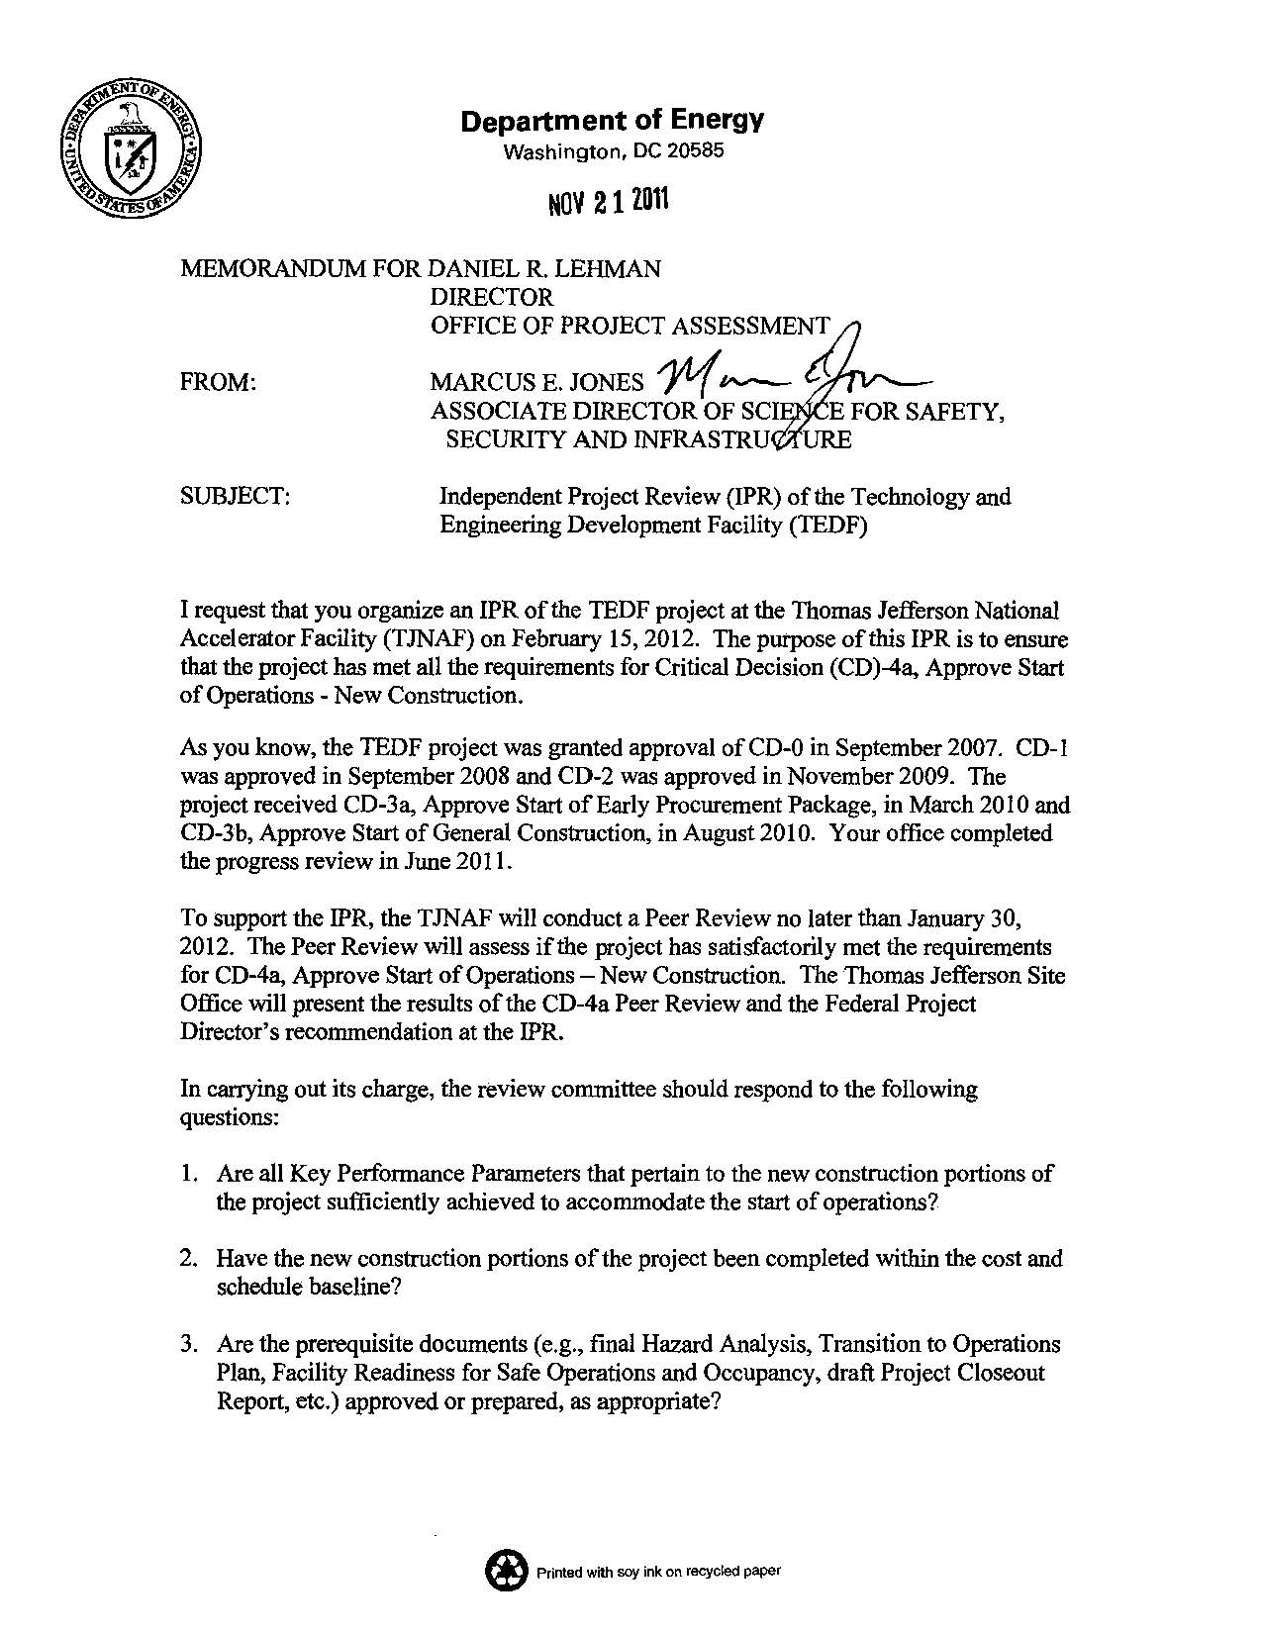

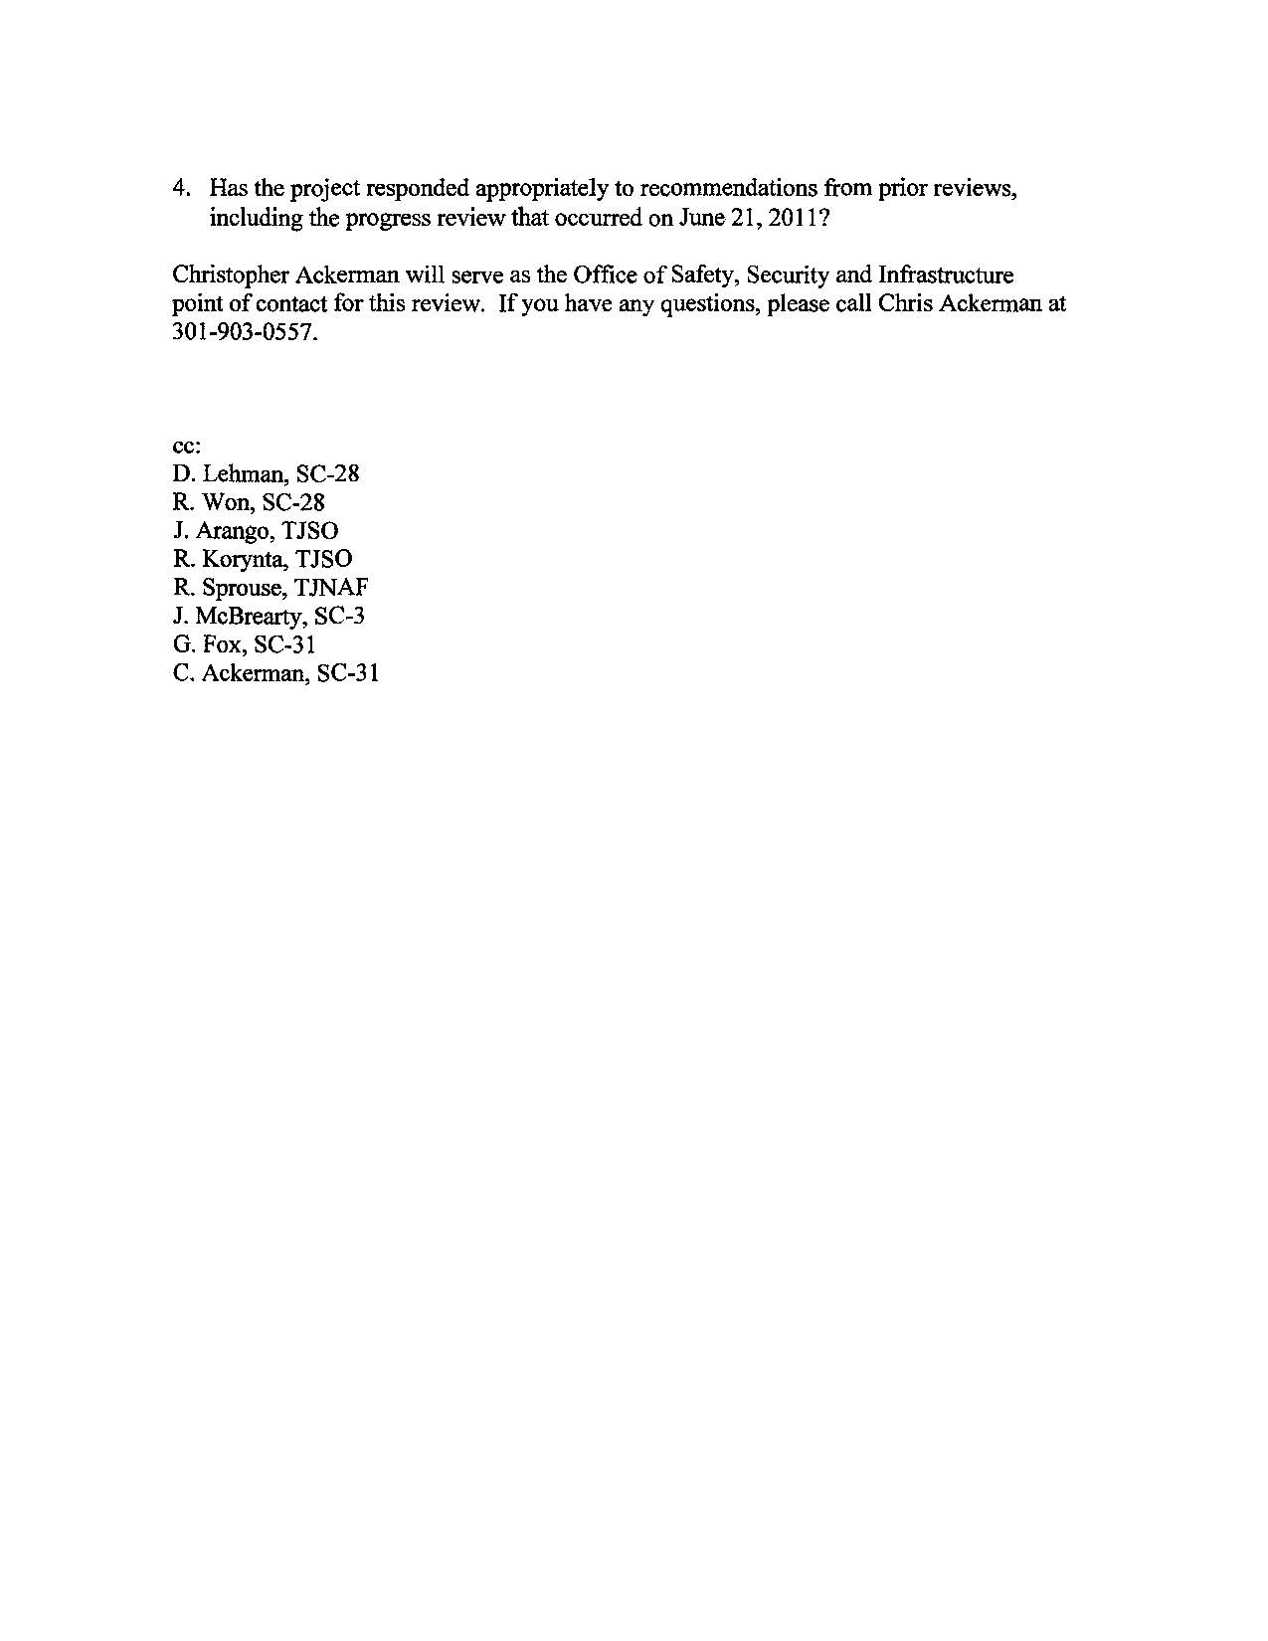

Appendix B:

Review Participants

**DOE/SC Review (CD-4) of the**

**Technology and Engineering Development Facility (TEDF) Project**

**February 15, 2012**

**REVIEW PARTICIPANTS**

**Department of Energy**

# Ray Won, DOE/SC, Chair

**Review Committee**

Jay Larson, DOE/SC

Ethan Merrill, DOE/SC

**Observers**

Gordon Fox, DOE/SC

Richard Korynta, TJSO

Chris Ackerman, DOE/SC

Joseph Arango, TJNAF

Appendix C:

Review Agenda

**DOE/SC Review (CD-4) of the**

**Building 51 and Bevatron Demolition Project**

**February 8, 2012**

**AGENDA**

**Wednesday, February 8, 2012—Germantown, H-209**

1:00 pm Preliminary Remarks Review Committee

1:10 pm PEER Review Results

1:30 pm FPD Presentation Barry Savnik

* Status of PEER Review Responses and Path Forward
* Status of CD-4a Prerequisites
* FPD Assessment and Recommendation

2:00 pm Question and Answer Session All

2:10 pm Executive Session Review Committee

2:30 pm Closeout